Section 3.7.3 Camera Pixel Numbering/Labelling Sequence

Pixel notation is expressed as a [*column*, *row*] index, where [0,0] is the pixel in the corner of the image area closest to both the serial register and the photon counting output amplifier (Figure 22). Pixel column indices increase in the +X direction of the Sensor CSYS, and pixel row indices increase in the +Y direction of the Sensor CSYS.

Pixel [528,520] represents the location of the thermally invariant pixel and thus is the center of the ExCam sensor CSYS while pixel [30,31] represents the center of a LoCam frame and is the center of the LoCam sensor CSYS.

Section 3.7.4 Camera Frame Formats

The EMCCD has a total image pixel area comprising of 2069 rows and 1056 columns. This active area is separated into a “lower” and “upper” image areas that are controlled independently by the proximity electronics depending upon the loaded readout sequence and frame format. SCI format frames correspond to readout the lower image area only and consist of 1200 rows by 2200 columns. The ENG frame format is 2200 rows by 2200 columns.

Both SCI and ENG formats have dimensions larger than the number of physical pixels on the CCD. Any row/column index greater than that present on the device produces an overscan pixel. These pixels only accumulate signal during the readout process and thus provide a useful reference for subsequent data processing; they do not represent a physical location in the detector CSYS.

Select regions of the array are covered with an aluminum light shield to act as a reference. While they are not optically sensitive, they are distinct from the overscan regions in the sense they still represent a physical location on the array (Figure 1):

1. The serial register and first 4 rows of the device are shielded with aluminum.
2. The leftmost 32 columns of the upper and lower image area are shielded.
3. The top 32 rows of the device are shielded.

Readout through the EM output is the default for all CGI operations and applies to sequences SCIENCE/ACQUIRE, TRAP PUMPING and ENGINEERING_EM (Table 1). The serial register is approximately a factor ×2 wider than the active area, and has a 180 bend approximately mid-way through. Signal transferred into the register from the active area occupies approximately half of the total number of columns read out within a single row. The leading half is not optically sensitive and is referred to as the serial prescan of the image. It is present in both SCI and ENG format frames.

An additional CONV CCD output is present on the device for debugging purposes and accessed through sequence ENGINEERING_CONV. Readout through this output is in the opposite column direction to the EM output and so the column orientation is flipped horizontally with the vertical orientation preserved. This results in fewer serial prescan pixels and an increase in the number of overscan pixels (Figure 5, Table 1).

Figures 2 through 5 show example SCI and ENG frames with image regions labelled. The projected orientation of an image consistent with Figure 37 is displayed for ExCam operating in Imaging Mode. Table 1 summarizes the physical regions of the detector accessible according to frame format and readout sequence.

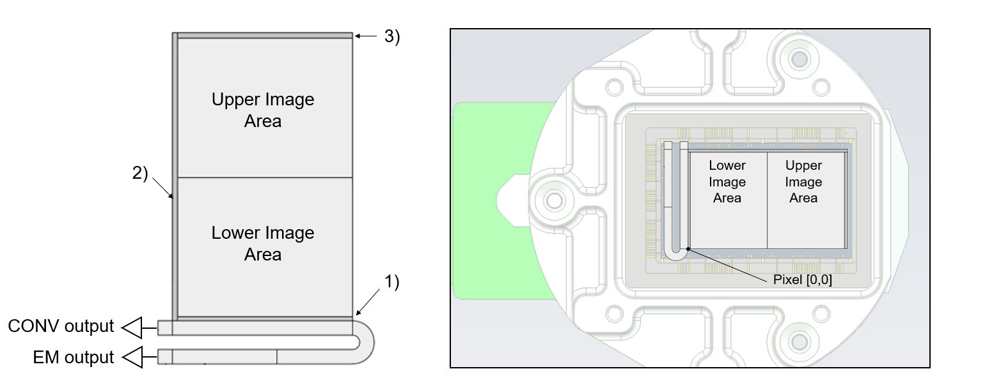

Figure 1 (left): CCD311 schematic showing the positioning of the lower and upper image areas, serial register, EM register and outputs. (Right) indication of orientation of device schematic with respect to invar package. The serial register and output are positioned adjacent to the PCB flex-board. For indication of detector orientation only; not to scale.

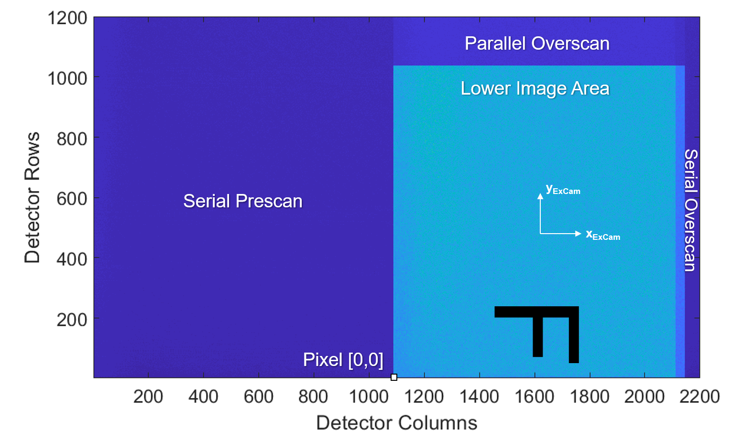

Figure 2: A SCI format image showing the location of prescan/overscan features, pixel index [0,0], and the axes of the ExCam sensor CSYS. The projected orientation of an image consistent with Figure 37 is displayed for ExCam operating in Imaging Mode.

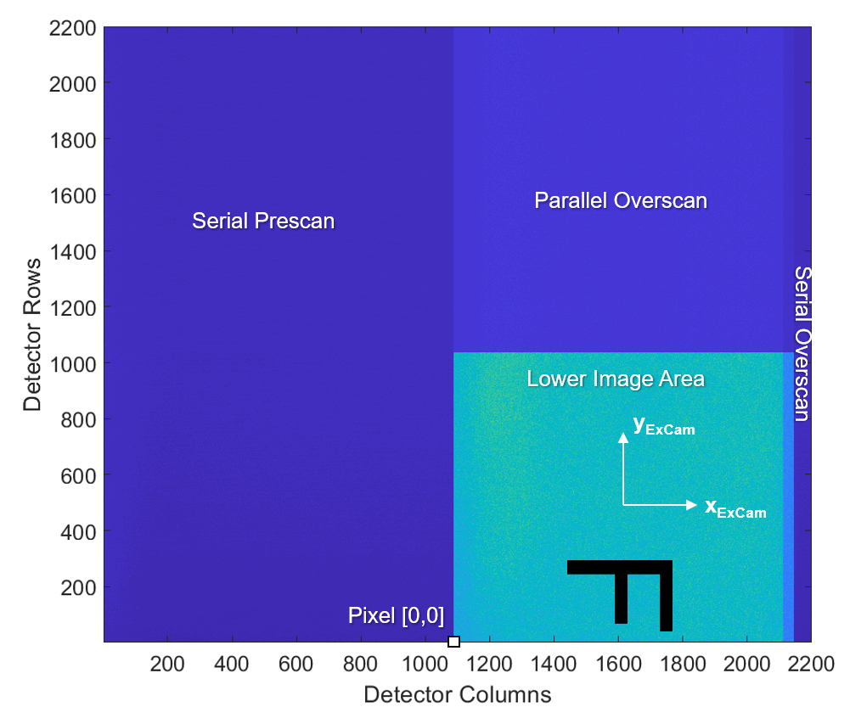

Figure 3: An ENG format frame obtained using either the SCIENCE or TRAP PUMPING readout sequence. Only the lower image area is accessed, the additional rows contain parallel overscan. The projected orientation of an image consistent with Figure 37 is displayed for ExCam operating in Imaging Mode.

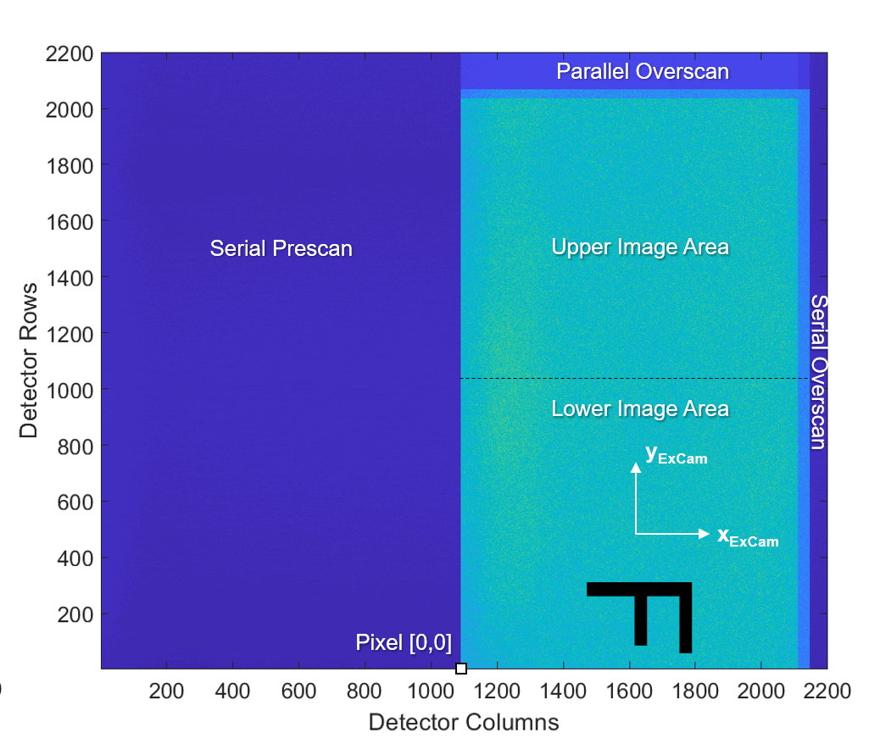

Figure 4: An ENG format frame obtained using the ENGINEERING_EM readout sequence. Both upper and lower image areas are accessed. The projected orientation of an image consistent with Figure 37 is displayed for ExCam operating in Imaging Mode.

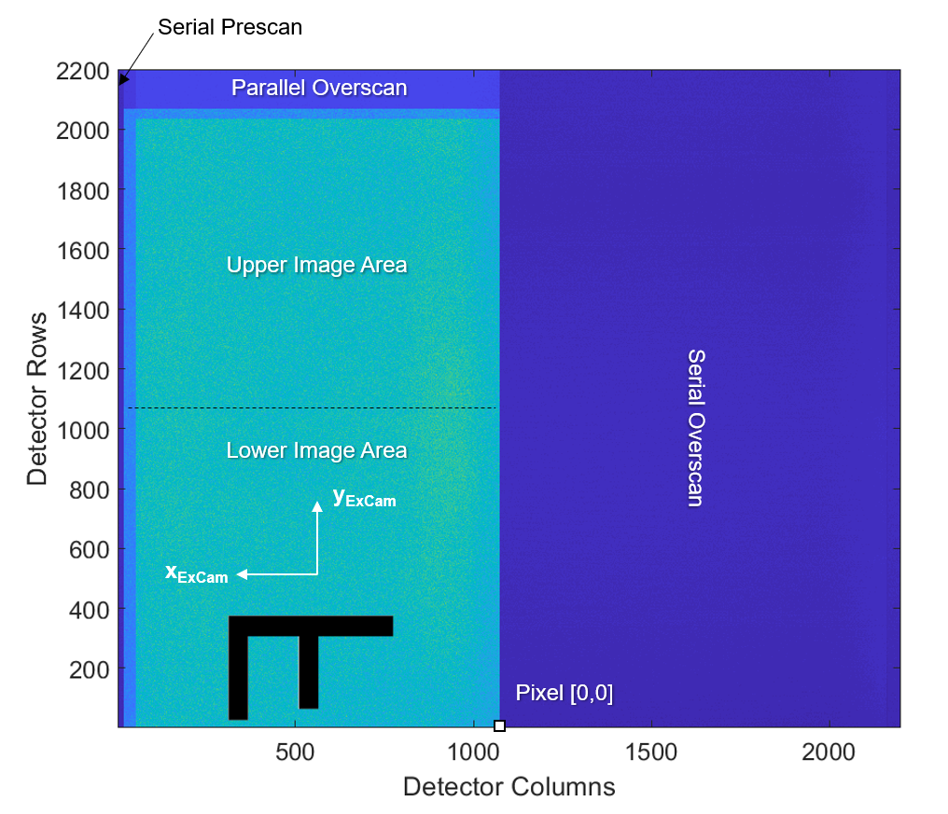

Figure 5: An ENG format frame obtained using the ENGINEERING_CONV readout sequence. Both upper and lower image areas are accessed. The horizontal (column) orientation is reversed due to reading the image through a different output. The projected orientation of an image consistent with Figure 37 is displayed for ExCam operating in Imaging Mode.

**Table 1**: Summary of default frame format with corresponding image area and overscan regions. The default formats for each sequence are shown in **bold**. Both SCI and ENG frames have the final row replaced with telemetry and so this row is not counted as an overscan pixel.

|  |  |  |  |  |  |
| --- | --- | --- | --- | --- | --- |
| Sequence (#) | Image Area  Read | Format | Parallel  Overscan  Pixels | Serial  Overscan  pixels | Serial  Prescan  pixels |
| SCIENCE/  ACQUIRE (1) | Lower Image | **SCI** | 162 | 40 | 1092 |
| ENG | 1162 |
| TRAP PUMPING (3) | Lower Image | SCI | 162 |
| **ENG** | 1162 |
| ENGINEERING_EM (4) | Upper and Lower Image | SCI | None |
| **ENG** | 130 |
| ENGINEERING_CONV (5) | Upper and Lower Image | SCI | None | 1128 | 16 |
| **ENG** | 130 | 1128 | 16 |

CGI can provide frames in either a ‘Raw’ or ‘Clean’ format (Table 2). Raw frames provide the entire as-read frame from the EMCCD with no intermediate processing, while clean frames represent a processed sub-section of the EMCCD array.

The geometry of a clean frame with respect to a raw frame is shown by Figure 6. For both raw and clean frames, pixel index [0,0] in the detector CSYS does *not* represent the first index in each of the arrays. Table 2 provides the mapping between frame pixel indexes and the detector CSYS. The row and column directions with respect to the detector CSYS are preserved for all frame formats, with the exception of CONV output frames that have the column direction reversed.

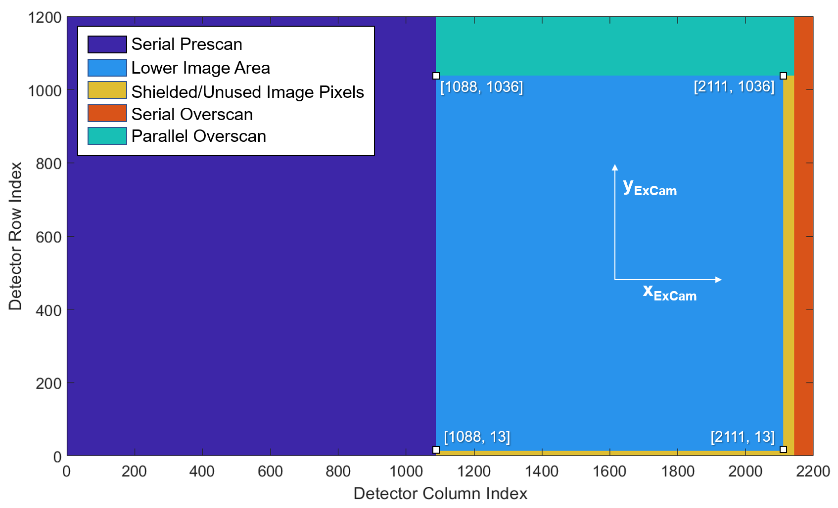

Figure 6: Geometry of a clean frame with respect to a raw frame. Indexing starts at [0,0].

Table 2: ExCam data formats and respective mapping of pixel index [0,0] in the detector CSYS.

|  |  |  |  |
| --- | --- | --- | --- |
| Format Name | Data type | Frame index of pixel [0,0] from detector CSYS | Frame index of pixel [528,520] from detector CSYS |
| ENG-sized Raw  (EM output) | [2200,2200] array of UINT16 | [1088,0] | [1616,520] |
| ENG-sized Raw  (CONV output) | [2200,2200] array of UINT16 | [1073,0] | [545,520] |
| SCI-sized Raw | [2200,1200] array of UINT16 | [1088,0] | [1616,520] |
| SCI-sized Clean | [1024,1024] array of FLOAT32 | [0,-13] | [528,507] |

Section 3.7.6 Viewing Image Data Products

Level 1 data products and above are formatted into 2D .FITS files. Ground truth is defined such that NAXIS1 corresponds to ExCam frame columns and NAXIS2 corresponds to ExCam frame rows, with array index [0,0] in raw frames corresponding to the first pixel adjacent to the device output. Different FITS viewers may interpret these data products differently and so some examples of a raw SCI Image with uniform background signal are provided with references to the detector CSYS.

By default, *SAOImage DS9, Astropy* and *Matlab* shall display a SCI sized raw frame as shown by Figure 7, Figure 8 and Figure 9, respectively.

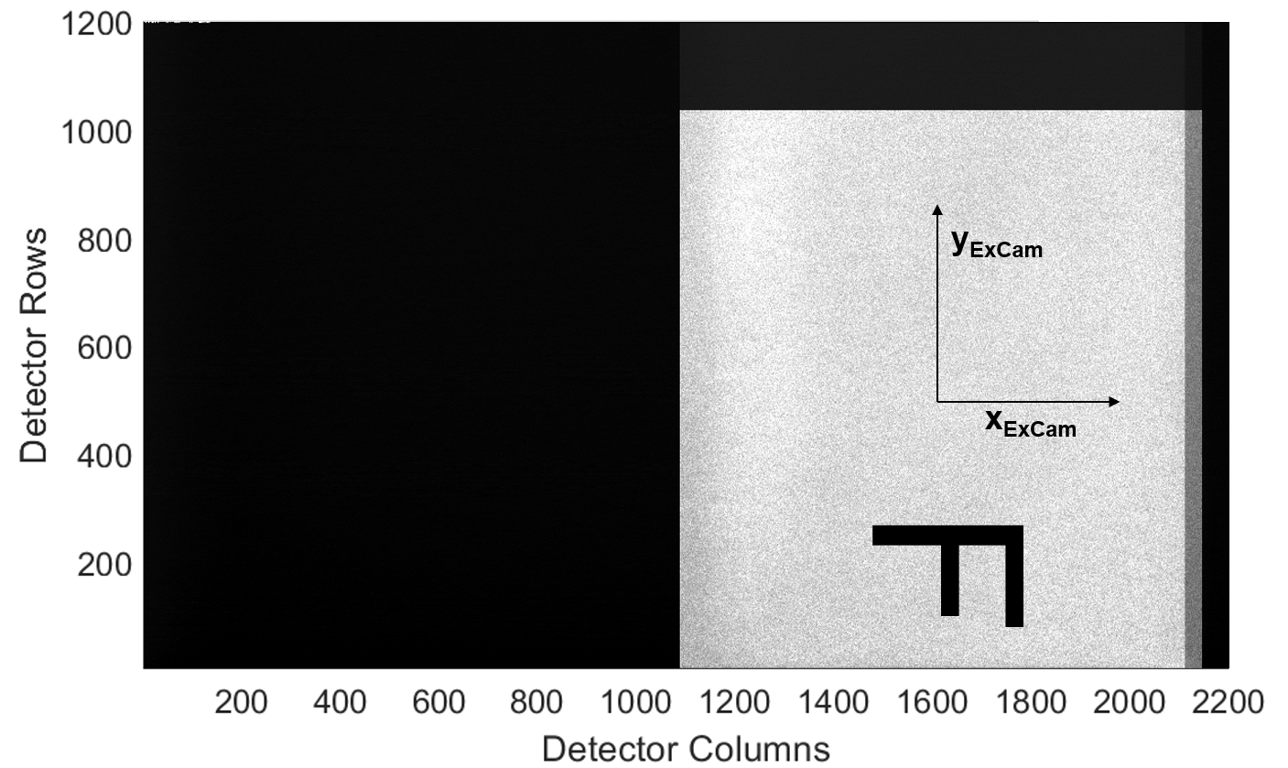

Figure 8: Default view of a SCI sized raw frame within SAOImage DS9

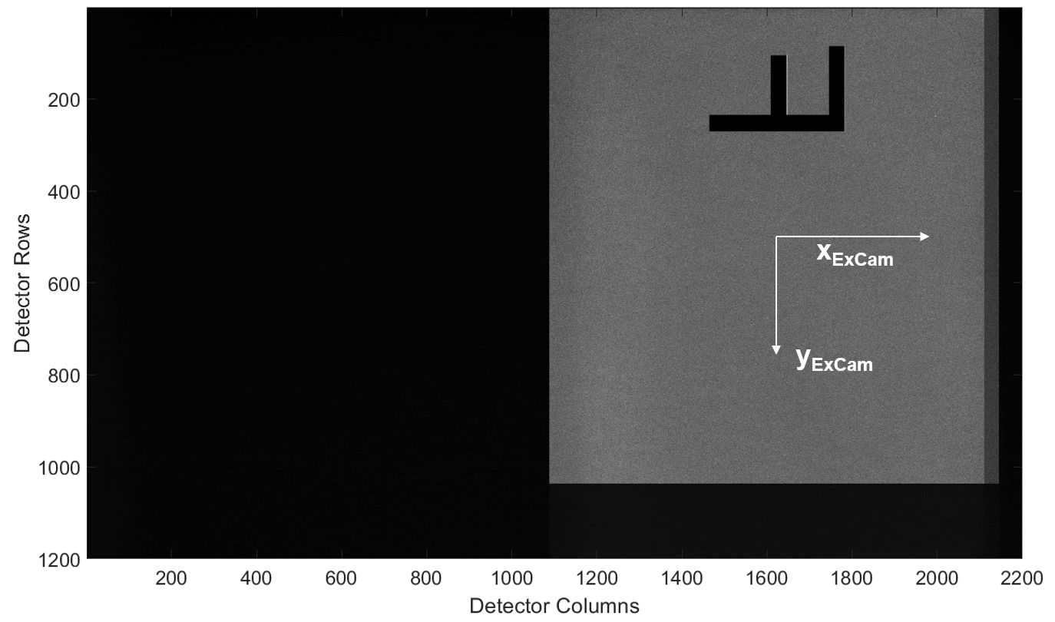

Figure 9: Default view of a SCI sized raw frame within Astropy

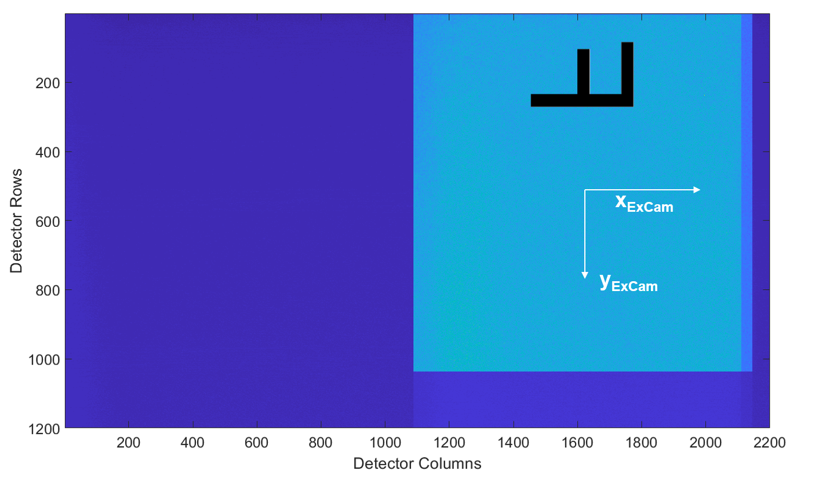

Figure 10: Default view of a SCI sized raw frame within Matlab